Full names: Ntombikayise Nhlanhlakazi Mtshweni
Student number: ST10529682
Subject name: Wed Development (WEDE5020)
Group no. 3


TABLE OF CONTENTS
Organisation 1: Fourways Farmers Market (small business) 3
1.) Organisation Overview: 3
2.) Website goals and objectives 4
3.) Current Website Analysis 4
Strengths: 4
Weakness: 4
4.) Proposed website Features and Functionality 4
5.) Design and User Friendly 5
6.) Technical Requirements 8
7.) Timeline Milestones 8
8.) Budget 9
9.) References 9

Part 1

Organisation 1: Fourways Farmers Market (small business)

Organisation Overview:
•Name: Fourways Farmer’s Market

•Brief history of organisation: Fourways Farmer’s Market, located at Taroko Farm, Norfolk Lane, Klipfontein 12-Ir, Lethabong, South Africa (Market, -), is a market where you can indulge in activities such as enjoying different food stalls, craft shopping and watching live music. The place is also family-friendly and pet-friendly, so you can enjoy yourself with your friends, family and your furry friends (Citizens, 2022). The founder, Greg Straw, is behind this family-friendly picnic park (quiet_apple, -); (Blaauwklippen, 2025). The main aim for this place is for individuals to enjoy themselves while they still shop ()

• Mission and vision statement:
- Vision: “To be the premier, vibrant community hub in Johannesburg, cultivating a sustainable, authentic, and welcoming environment that connects local, artisanal producers directly with consumers in a scenic outdoor setting” (Citizens, 2022)
“A smart fresh produce trading hub that is globally competitive” (Market, 2026) .

- Mission: “To curate a high-quality weekly market experience that supports small, local farmers and artisans, offering fresh produce and handcrafted good to our community, while fostering a vibrant atmosphere for families and pet owners to connect, shop and relax.” (Market, -)
“To provide the best environment that supports competitive trade and effective distribution of fresh produce products in Southern Africa.” (Market, 2026)

Website goals and objectives
- The goal of the website is to populate to the audience the beautiful views of the place, as well as what they offer, such as live music and food & drinks, and what they allow in the premises, for example, the place is dog friendly. The website also displays upcoming events hosted at the place, as well as a space where you can hire a spot where you can sell your products, and where you can do your performances. It also displays the history of the “Stone House gardens”, as well as its significance.

- The key performance for this business is the number of visitors, the number of repeat visits, as well as the total number of sales. Community engagement can also be one of the key performance indicator.

Current Website Analysis

Strengths:
- The website does show adequate amount of information for the customers who are interested in the business.
- There are beautiful images that display the business location.

Weakness:
- The website is hard to navigate.
- The website does not give full details about the business.

Proposed website Features and Functionality
- Homepage (default)
  - The homepage will display the hero image of the website, as well as a banner which displays an image of the place and what they offer.
- Upcoming Event
  - It will display images of upcoming events and their information, such date and time
- About
  - It will display what this business is about as well as its purpose.
- Sports bar
  - This displays information about the business hosting, so that people are able watch games if they’d like to.
- Venue Hire
  - It will display a enquire button for people who would like to host an event at a certain place.
- Vendor directory
  - It will display different types of items sold in the business, such as food, plants etc.
- Contact
  - A form will be displayed should anyone wish to contact us.

Design and User Friendly
- Colour Scheme: There are various shades of green, to show a hint of nature, and the whole aesthetic of the market.
- Typography: Primary Heading and Navigation: Montserrat
Body text and secondary information: Avenir (Avenir Next)
Fallout Fonts: Sans-serif ( In case the primary fonts do not load) (AI, 2026)
- Layout and Design: It is designed like a one-page, so if you click on the menu, it will automatically scroll down to the specified heading.
- User experience considerations: Anyone is able to access the website, and it allows you to navigate with ease. The colours are complementary to each other. The website has a fill-in space for anyone interested in selling or hosting an event at the place. It displays information for anyone interested in the history of the market and how it came to be.
- Low-fidelity wireframe:
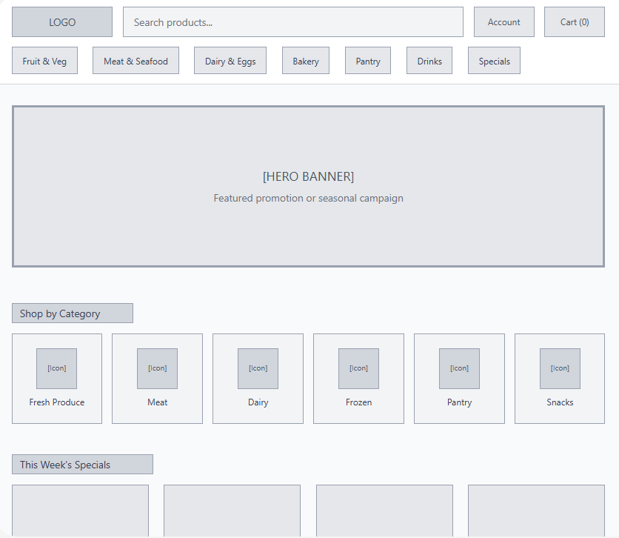
Homepage:
Contact: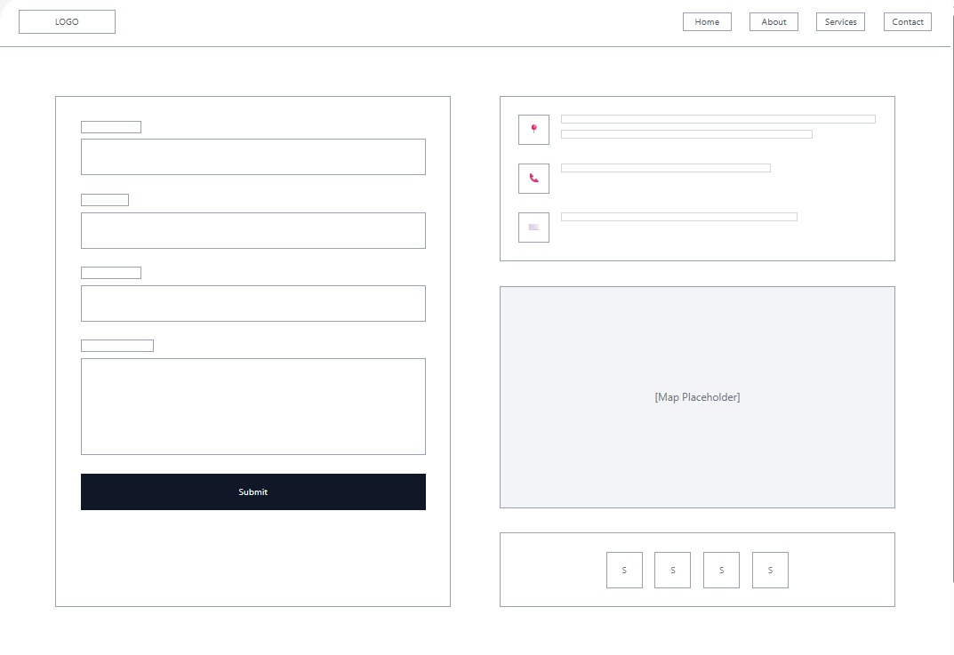
Enquiry:
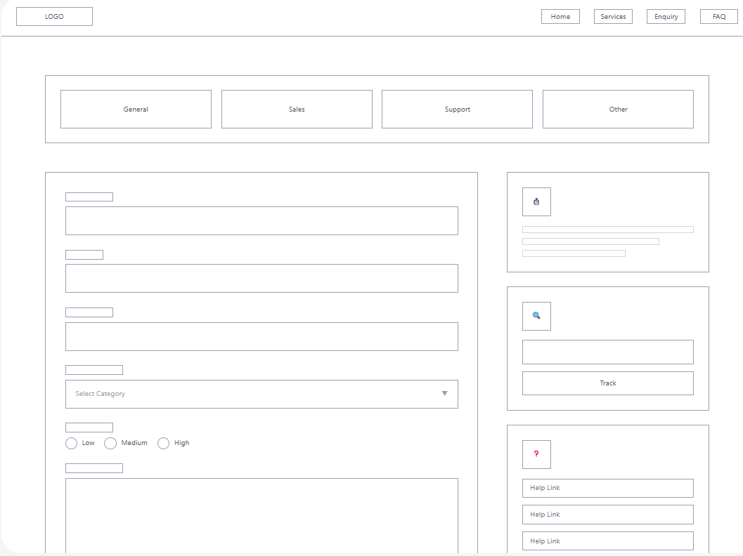
Products:
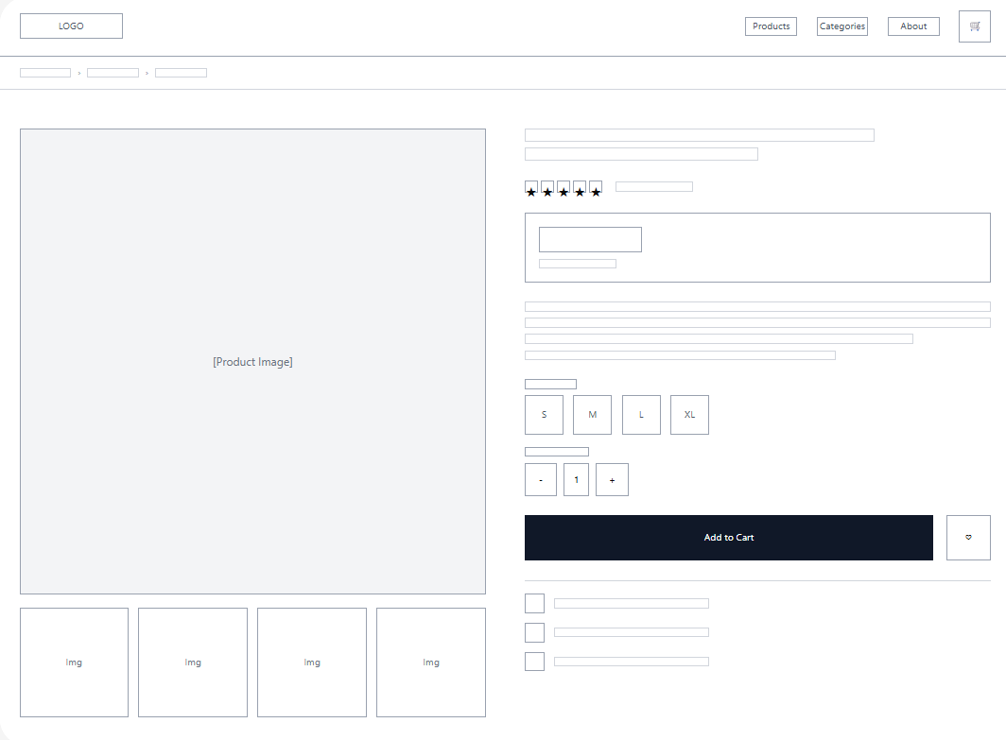
About us:

Technical Requirements
- HTML
- CSS
- JavaScript
- Visual Studio Code

Timeline Milestones
- Week 1
  - Plan: Planning and research of the project
  - Tasks done: Thorough research of the proposal and define the idea of the project
  - Milestone: Project plan complete
- Week 2
  - Plan: Design of the website
  - Tasks done: Draft/wireframe of the project
  - Milestone: Draft complete
- Week 3 - 5
  - Plan: Development of the website
  - Task done: Building the HTML structure of the website
  - Milestone: HTML structure complete
- Week 6 - 8
  - Plan: Development of the website
  - Task done: Incorporating CSS structure to the website
  - Milestone: CSS structure incorporated
- Week 9
  - Plan: Development of the website
  - Task done: Incorporating JavaScript structure to the website
  - Milestone: JavaScript structure incorporated
- Week 10
  - Plan: Finalisation of the website
  - Task done: Testing the functionality of the website
  - Milestone: Website complete and functional

Budget
- Development: R5 500
- Hosting: R2 500 per hour
- Maintenance: R50

References
AI, G., 2026. Font used on the website for Fourways Farmers Market, Pretoria: gemini.ai.
Blaauwklippen, 2025. Blaauwklippen welcomes Greg Straw, visionary landscape architect and horticulturist. [Online]
Available at: https://news.wine.co.za/news.aspx?NEWSID=45397
[Accessed 11 March 2026].
Citizens, T., 2022. Fourways Farmer’s Market owner gives ‘groove’ the green light. [Online]
Available at: https://www.citizen.co.za/lifestyle/entertainment/fourways-farmers-market-gives-groove-greenlight/
[Accessed 29 March 2026].
Market, F. F., -. 4ways Farmers Market. [Online]
Available at: https://www.4waysfarmersmarket.com/
[Accessed 11 March 2026].
Market, J., 2026. Joburg Market. [Online]
Available at: https://joburgmarket.co.za
[Accessed 11 March 2026].
quiet_apple, -. Greg Straw in Entrepreneur Magazine. [Online]
Available at: https://share.google/e4ouzAEdxqmuudMS3
[Accessed 11 March 2026].
Studocu, 2026. Studocu. [Online]
Available at: https://www.studocu.com
[Accessed 11 March 2026].

